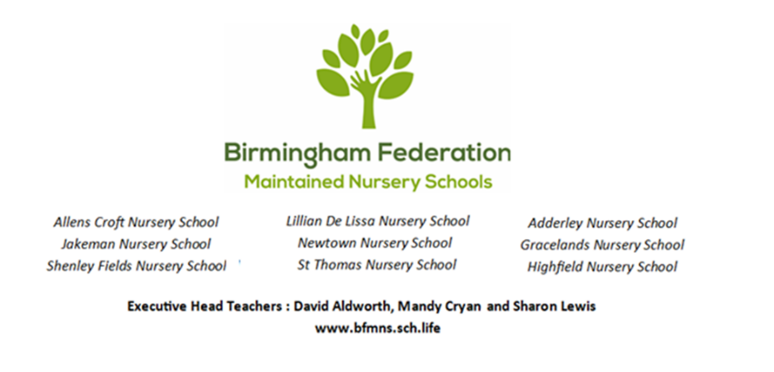

Birmingham Federation of Maintained Nursery Schools
Equality Statement and Objectives

1. Statement of Intent
At the Birmingham Federation of Maintained Nursery Schools, we are committed to ensuring equality of opportunity for all our children, families, staff, and community members. We celebrate the diversity of our local community and believe that every individual has a right to be treated with dignity, respect, and fairness.
As Local Authority Maintained Nursery Schools, we welcome our duties under the Equality Act 2010 and the Public Sector Equality Duty (PSED). We actively eliminate discrimination, advance equality of opportunity, and foster good relations across all areas of school life. Our schools are not only committed to eliminating discrimination but increasing understanding and appreciation for diversity too. We ensure that our early years provision is fully accessible, inclusive, and culturally enriching.

2. Legal Framework and the Public Sector Equality Duty (PSED)
We welcome our duties under the Equality Act 2010 to eliminate discrimination and advance equality across the nine protected characteristics:
- Age
- Disability
- Gender reassignment
- Marriage and civil partnership
- Pregnancy and maternity
- Race (including colour, nationality, and ethnic or national origin)
- Religion or belief
- Sex
- Sexual orientation

Creating a prejudice free environment where all members of our Federation community feel confident and at ease is a priority for us and is supported by the following principles:
- Being respectful
- Treating everyone fairly – fair access and opportunity for everyone
- Understanding diversity and the benefits it has
- An inclusive attitude
- Encouraging compassion and open mindedness
- A culture that enables brave discussions and appropriate challenge
- Ensuring every voice is heard

We integrate the three core aims of the Public Sector Equality Duty (PSED) into our daily early years practice:
- Eliminate unlawful discrimination, harassment, and victimisation.
- Advance equality of opportunity between people who share a protected characteristic and those who do not.
- Foster good relations across all characteristics by tackling prejudice and promoting understanding.

3. Guiding Principles for Our Early Years Provision
To ensure our youngest learners thrive in an environment free from bias, we embed the following principles into our curriculum, environment, and daily school life:
- An Inclusive Curriculum: We ensure that our Early Years Foundation Stage (EYFS) curriculum offers diverse representation. Books, toys, and resources positively reflect different ethnicities, cultures, religions, family structures, disabilities, and genders.

- Rights of the Child: We ensure that the rights of the child are at the heart of the Federation’s ethos and culture and that children’s rights are learned, taught, practised, protected and promoted.

- Removing Barriers: We actively identify and dismantle barriers to learning and participation. This includes ensuring physical accessibility and providing robust support for children with Special Educational Needs and Disabilities (SEND).

- Community Cohesion: We value and celebrate the languages, heritages, and faiths of our families and diverse staff teams.

- Fair Employment Practice: We ensure that our recruitment, promotion, and professional development processes are transparent, non-discriminatory, and comply fully with Local Authority HR guidelines.

4. Our Equality Objectives (2026–2030)
In line with our statutory duties, we review and publish specific, measurable equality objectives at least once every four years. Our objectives are:
- Objective 1: Narrow the Achievement Gap
To assess, track, and close any gaps in attainment and progress between distinct groups of children, particularly focusing on those eligible for Early Years Pupil Premium (EYPP), children with SEND, and those learning English as an Additional Language (EAL).

- Objective 2: Enhance Diverse Representation
To continuously review our learning environments and resources to ensure they reflect the rich diversity of the School community and modern world, explicitly challenging gender stereotypes and celebrating multiculturalism.

- Objective 3: Promote Inclusive Family Engagement
To ensure all school communications, parent workshops, and community events are accessible to all families, providing translation services and any other support where required to foster a deeply inclusive school community.

We understand that equality is not about ‘treating everybody the same’ but actively giving children and adults the support, they need to reach their full potential.

5. Roles and Responsibilities
- The Governing Body is responsible for ensuring that the school complies with all relevant equality legislation and that this statement and its objectives are implemented effectively.

- The Executive Headteachers / Head Teacher are responsible for implementing the policy daily, ensuring all staff receive appropriate training, and handling any incidents of unfair discrimination or prejudice.

- All Staff are expected to model inclusive behaviour, and ensure that every child receives equitable support to reach their full potential.

We believe that promoting equality is the responsibility of everyone in our School Community.

Review Date: September 2027
Next Objective Publication Date: September 2030

